African Wild Dog Dispersal and Connectivity under Climate Change - Lessons Learned from Seasonal Flood Extremes

David D. Hofmann1,2,§

Dominik M. Behr1,2

John W. McNutt2

Arpat Ozgul1,2

Gabriele Cozzi1,2

Climate change is expected to profoundly impact the life history of wild-living animal populations. While the impacts of climate change on the demographics of local subpopulations have been studied repeatedly, little is known about the consequences for dispersal and connectivity.

We capitalize on a “natural experimental setup”, the flood-pulse driven change in surface-water across the Okavango Delta in northern Botswana, to investigate the impact of changing environmental conditions on dispersal patterns and connectivity of the endangered African wild dog (*Lycaon pictus*). For this, we simulate dispersal trajectories across the Okavango Delta under two extreme scenarios that serve to represent environmental conditions akin to those expected under continued climate change; one assuming a maximum flood, one assuming a minimum flood.

During maximum flood, the Okavango Delta poses an important dispersal barrier that reduces dispersal prospects in increases dispersal durations between distinct areas. Across the entire study area, we observe $\input{99_NumberReachingOthersPercentage.tex}$% lower dispersal success and $\input{99_StepsToReachingOthersPercentage.tex}$% longer dispersal durations during maximum flood. Most notably, dispersal into the central habitats of the Okavango Delta is reduced by $\input{99_NumberReachingArea6Percentage.tex}$% with an accompanied increase in dispersal durations of $\input{99_StepsToReachingArea6Percentage.tex}$%. Depending on the flood, dispersal corridors traversed different areas and dispersers moved into proximity of different human-dominated areas.

Whilst the exact impacts of climate change on the flooding regime of the Okavango Delta remain unknown, our results suggest that connectivity will vastly differ depending on future flood conditions. Acknowledging such differences will be key to design effective conservation strategies, especially in light of ongoing climate change. Since we highlight critical dispersal corridors and human-wildlife conflict zones for two distinct future scenarios, our results will facilitate the evidence-based conservation of the endangered African wild dog.

1 Department of Evolutionary Biology and Environmental Studies, University of Zurich, Winterthurerstarsse 190, 8057 Zurich, Switzerland.

2 Botswana Predator Conservation Program, Wild Entrust, Private Bag 13, Maun, Botswana.

§ Corresponding author: david.hofmann2@uzh.ch

**Running Title:** African Wild Dog Dispersal in a Changing Climate: Lessons Learned from Seasonal Flood Extremes

**Keywords:** movement, connectivity, climate change, seasonality, dispersal, conservation, individual-based simulations, step-selection

# Introduction

## Climate Change and Dispersal

Climate change is expected to profoundly impact ecosystems across the globe with far-reaching consequences for the species living therein (Ozgul et al. 2010; **???**; **???**). By altering environmental conditions, climate change affects animal behavior (**???**), resource availability (**???**), population dynamics (**???**), and the distribution of wild living animal populations (**???**; **???**). An important life-history pathway through which species may mediate the negative consequences of climate change is dispersal (**???**), i.e. the movement of individuals away from their natal location to the site of first reproduction (Clobert et al. 2012). Through dispersal, species may adapt to climate change by tracking favorable habitat conditions (**???**) and by shifting into a different region of their fundamental niche (Kokko 2006). Dispersal also facilitates the colonization empty habitats (Gustafson and Gardner 1996; Hanski 1999; MacArthur and Wilson 2001), promotes the reinforcement of weakened and small subpopulations (Brown and Kodric-Brown 1977), and safeguards genetic diversity (Frankham, Briscoe, and Ballou 2002; Leigh et al. 2012; Baguette et al. 2013), thus providing additional resilience against changing environmental conditions (Kokko 2006; Fahrig 2003).

## Connectivity

While dispersal offers a means to offset the negative demographic consequences of climate change (Kokko 2006; Hodgson et al. 2009; **???**), it itself is a function of climatic and environmental conditions (e.g. (Elliot et al. 2014; Behr et al. 2020)). The link between dispersal and the environment can either be indirect, for example if the propensity of individuals to disperse depends on environmental conditions, or direct, when the biophysical environment through which dispersers move affects dispersal prospects (**???**). The latter highlights that dispersal is also inextricably linked to the concept landscape connectivity (Baguette et al. 2013), which is understood as the degree to which the landscape facilitates or impedes movements (Taylor et al. 1993). A sufficient degree of landscape connectivity is thus a critical prerequisite for successful dispersal (Fahrig 2003), yet the continued degradation and destruction habitats worldwide continues to imperil the dispersal prospects of many species (**???**; Sawyer, Epps, and Brashares 2011). Conservation strategies that aim at facilitating dispersal by improving landscape connectivity are therefore often viewed as pinnacle of all conservation strategies (Heller and Zavaleta 2009). Despite this, our understanding of dispersal and its implications for connectivity is limited, especially in light of changing environmental conditions.

## Modeling Connectivity

To study dispersal and connectivity, various modeling techniques have emerged (see e.g. (Etherington 2016) and (Diniz et al. 2019) for overviews). Initially, the techniques were limited to examining structural aspects of connectivity by focusing on the composition and configuration of habitat patches, while ignoring species’ responses to the landscape matrix (Tischendorf and Fahrig 2000; Doerr, Barrett, and Doerr 2011). With the increasing availability of telemetry data and methods to study species’ habitat and movement preferences (Boyce et al. 2002; Fortin et al. 2009; Cushman and Lewis 2010; Avgar et al. 2016), preferably during dispersal (Elliot et al. 2014), however, the focus has shifted towards a more functional view on connectivity, which also takes into account how species interact with their surroundings (Tischendorf and Fahrig 2000; Doerr, Barrett, and Doerr 2011). Currently, the most prominent *functional* connectivity models are based on least-cost path analysis (LCPA, (Adriaensen et al. 2003)) and circuit theory (CT, (McRae et al. 2008)), two graph-based methods that estimate conductance of the landscape by means of a resistance (or inversely permeability) surface (Zeller, McGarigal, and Whiteley 2012). Such a surface is meant to reflect the ease or willingness at which the focal species traverses a specific area and is generated by consolidating multiple habitat layers into a single layer of resistance (Zeller, McGarigal, and Whiteley 2012). Since both LCPA and CT approaches make assumptions that are rarely met by dispersing individuals, individual-based movement models (IBMMs), in which dispersal movements are simulated explicitly, have also gained some momentum (Kanagaraj et al. 2013; Allen, Parrott, and Kyle 2016; Hauenstein et al. 2019; Diniz et al. 2019; Zeller et al. 2020; **???**; **???**; **???**). IBMMs provide great modeling flexibility and are thus considered powerful tools for examining connectivity under different landscape configurations (**???**; **???**). However, most connectivity studies focus on a snapshot in time and fail to account for changing environmental conditions, such as those akin to climate change. Moreover, the challenges associated with studying dispersing animals further impairs the collection of data during dispersal at the appropriate temporal and spatial scale (**???**; Vasudev et al. 2015) and weakens our ability to project dispersal prospects under changing environmental conditions into the future.

## Climate Change and Seasonality

Predicting the impacts of climate change on dispersal and connectivity is non-trivial and typically requires spatial information about future climatic or environmental conditions over the area of interest (**???**). This information can then be used in various ways. (**???**), for example, combined climatic predictions until 2070 with a species-distribution model for mountain newts (*Neurergus kaiseri*) in Iran to demonstrate a decrease in connectivity due to increased habitat fragmentation. Similarly, (**???**) mapped the future distribution of the giant spiny frog (*Quasipaa spinosa*) under different representative climate pathways and reported a reduction in connectivity for the species across South-East Asia. In these studies, the focus lies on the impacts of climate change on species distribution and subsequent changes in connectivity due to the configuration of habitat patches, yet less on the habitat matrix and its implications for dispersal. For martens, (*Martes americana*), (**???**) developed several resistance layers emerging under different climate scenarios and find that already low warmings will result in increased isolation of remaining subpopulations. While not primarily focused on climate change, another body of literature captures environmental variability by generating resistance surfaces for different scenarios. (**???**), for instance, developed seasonal resistance maps for Blanding’s turtle *Emydoidea blandingii* showing that connectivity was substantially lower in late summer compared to spring. Similarly, (Osipova et al. 2019) studied connectivity for African elephants (*Loxodonta africana*) during wet and dry season and found that ignoring seasonality resulted in an underestimation of connectivity during the wet season and an overestimation during the dry season. For the same species, (**???**) provide monthly updated connectivity maps revealing that connectivity varies strongly across a typical year. Finally, (Zeller et al. 2020) use dynamic resistance surfaces showing differences in connectivity for black bears *Ursus americano*. Altogether, the studies exemplify that connectivity should not be regarded as static in time, but dynamic across and within years.

In many cases, anticipating environmental conditions under climate change is not viable as relevant data is not available or entails major uncertainty (**???**). This is particularly true for complex ecosystems with intricate feedback loops and in cases where one is interested in landscape characteristics, rather than climatic conditions. In general, it is accepted that aside from increasing temperatures, climate change will also amplify the frequency and magnitude of extreme events, such as severe droughts, heavy precipitation, floods, and storms (**???**; **???**; **???**). Thus, instead of attempting to study the impacts of climate change directly, one may capitalize on naturally occurring fluctuations of the environment to gauge the likely consequences of shifting the system towards what is currently considered an extreme.

## Okavango Delta

The Okavango Delta (OD) in Southern Africa poses a unique opportunity to study the impacts of extreme environmental change on species dispersal ability and connectivity in a large scale natural experiment setup. The OD is the world’s largest inland delta and characterized by substantial seasonal differences in surface-water cover. Throughout the course of a year, the area covered by the OD’s floodwaters can fluctuate between 3’000 and 10’000 km2 with striking variability within and between years (Gumbricht et al. 2004; Wolski et al. 2017). Importantly, the region is among the most vulnerable to climate change, as a temperature increase of 4 to 6C above pre-industrial levels is expected within the 21st century (**???**; **???**), which is far beyond the global average (**???**). A keystone predator in this ecosystem and an umbrella species for conservation efforts is the African wild dog (AWD, *Lycaon pictus*). While the species was once widespread across across entire Sub-Saharan Africa, it has disappeared from a vast majority of its historic range, mainly due to human persecution, deadly diseases, and continued destruction and degradation of its habitats (Woodroffe and Sillero-Zubiri 2012). AWDs are characterized by an unsurpassed dispersal ability, as young individuals that leave their natal pack can cover several hundred kilometers within a few days (**???**; Masenga et al. 2016; Cozzi et al. 2020). Dispersal typically happens in dispersal coalitions of same-sex siblings (McNutt 1996). Previous research has shown that the ODs floodwaters pose a major dispersal barrier, yet the analysis was centered around an average flooding scenario (Hofmann et al. 2021).

## What We Did

Here, we utilize a previously parameterized and validated dispersal model as IBMM to simulate dispersal and assess dispersal success and connectivity patterns for African wild dogs under two extreme scenarios: one assuming maximum flooding of the Okavango delta and one assuming minimum flooding of the Okavango delta. The IBMM was trained using GPS data collected during dispersal and frequently updated environmental data, thus providing a high degree of realism (Hofmann et al. 2021). Given that dispersers avoid crossing through water (albeit we do occasionally observe it in the field), we anticipated that dispersal prospects and connectivity during maximum flood would be low. Moreover, when the flood extent of the OD is at its maximum, the water extends almost into the densely populated village of Maun. Since both the flood and humans are avoided by dispersing wild dogs, we anticipated that a fully flooded Delta would result in a total halt of movement between the Western and Eastern side of the OD. Information on habitat selection or connectivity is also suitable for predicting areas with an elevated potential for human wildlife conflict (**???**). Hence, also quantified areas with high potential for human wildlife conflict.

# Materials and Methods

We conducted all data preparation and analyses using the programming language R (**???**). For any spatial data manipulation, we used the packages terra (**???**) and spatstat (**???**). Several helper functions for the dispersal simulation algorithm were written in C++ and imported to R using the Rcpp package (Eddelbuettel and François 2011). Network analysis was achieved in igraph (**???**) and figures were generated using ggplot2 (**???**) and ggnetwork (**???**). All R-scripts required to replicate our analyses are provided through an online repository.

## Study Area

The study area for this analysis was focused on the Okavango delta (OD) and its surroundings in Southern Africa, comprising parts of Angola, Namibia, Botswana, Zimbabwe, and Zambia (). While our primary focus lied on the immediate surroundings of the Okavango Delta, we considered an extended rectangular extent stretching from 20’ E to 26E. This encompasses a total of 300’000 km2) and comprises all long distance dispersal events previously recorded in this area (Cozzi et al. 2020; Hofmann et al. 2021). The annual flood-pulsing rhythm of the OD is mainly dictated by precipitation in the Angolan highlands, which serve as catchment areas from which water is further channeled into the Okavango River and transported into the OD (Wolski et al. 2017). Although precipitation reaches its maximum between December and March, the collected water only slowly descends through the Okavango River and its distributaries, reaching the distal ends of the delta only towards July or August. In result, peak flooding is out of sync with local precipitation, such that the flood usually arrives in the OD during the peak dry season. Once the water reaches the OD’s distal ends, it percolates at the Thamalakane and Kunyere Faults, two natural faultlines at which the waterflow is hindered. During minimum extent, the flood covers an area of only 3’600 km2, whereas during maximum flood more than 9’000 km2 are flooded. Vegetation in this study area is dominated by mopane forest, mixed acacia woodland, and grassland. Human influence is low and mainly concentrated around small villages at the western periphery of the OD as well as the city of Maun at the south-eastern tip of the OD. Large portions of land are dedicated national parks, game reserves or forest reserves. The study area is also part of the world’s largest transboundary conservation initiative, the Kavango-Zambezi Transfrontier Conservation Area. Previous studies have attributed a high potential of this initiative for improving connectivity for various species (Brennan et al. 2020; **???**; Hofmann et al. 2021).

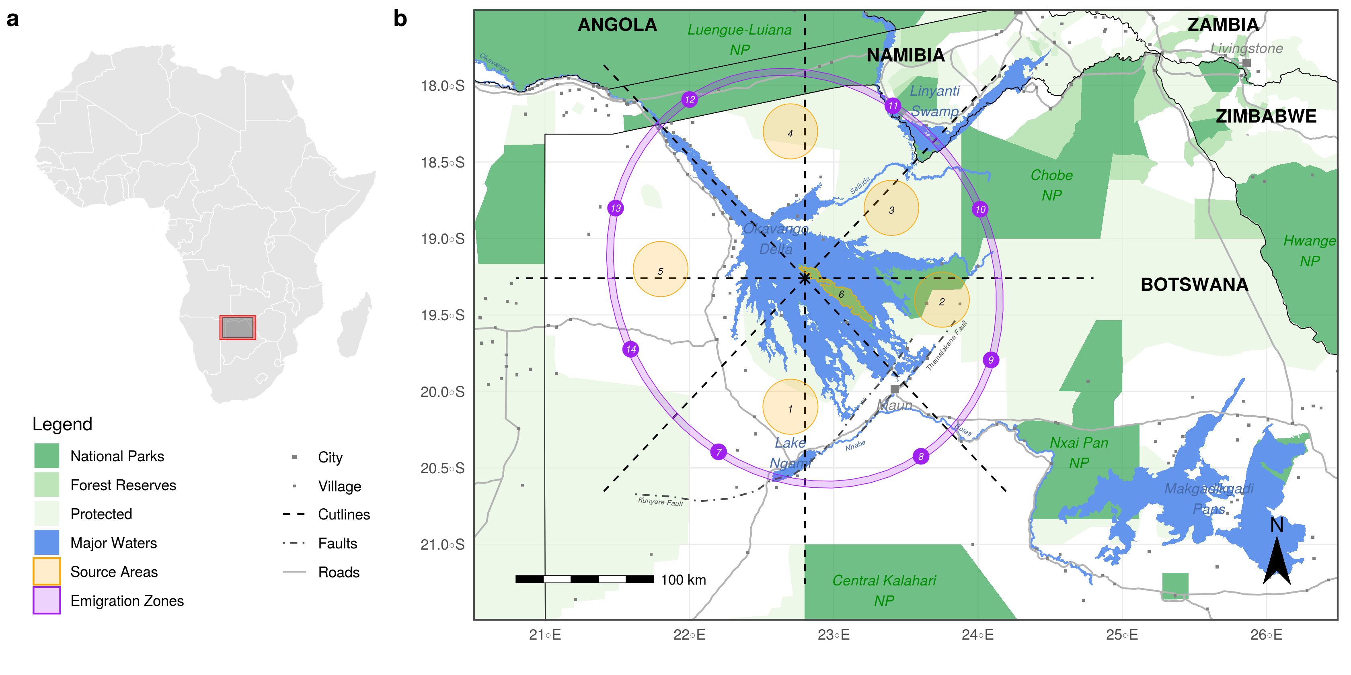

(a) Location of the study area in Southern Africa across which we simulated dispersing African wild dogs. To mitigate edge effects, our study area comprised a buffer zone (red polygon) within which we randomized covariate values of the habitat layers. (b) The study area was centered on the Okavango Delta and encompassed its immediate surroundings. We initiated simulated dispersers at random locations within one of the six source areas (orange polygons) that we distributed across the delta. Emigration zones (purple polygons) served as checkpoints to identify if and where simulated dispersers left the close surroundings of the Okavango delta. These zones were generated using a set of cutlines (black dotted lines) originating from the center of the delta that dissected an elliptical buffer surrounding the delta into sections of equal size and in accordance with the cardinal directions.

## Spatial Habitat Layers

We represented the physical landscape through which dispersers could move by a set of spatially referenced habitat layers, each with a resolution of 250 m. The set of layers included water-cover, distance-to-water, tree-cover, shrub/grassland-cover, and a human influence layer depicting anthropogenic influences through villages, roads, and agriculture. A detailed description of the different habitat layers is provided in (Hofmann et al. 2021). Importantly, the water-cover and derived distance-to water layers were generated using MODIS Terra MCD43A4 satellite imagery that was classified into binary water-cover maps using a “floodmapping” algorithm developed by (Wolski et al. 2017). This allowed us to generate almost weekly updated “floodmaps”, thus providing detailed information about the flood-extent at any given point in time. In total, we generated 700 floodmaps between the years 2000 and 2019, based on which we generated a minimal and maximum flood scenario. To create the minimum (maximum) flood scenario, we averaged the 50 floodmaps with the smallest (highest) flood extent and generated a binary layer by masking all pixels that were inundated in less than 50% of the maps. The resulting maps are presented in . Ultimately, we combined the habitat layers into two stacks, one representing the minimum flood scenario, one representing the maximum flood scenario. To mitigate edge effects during the dispersal simulation, we followed (Koen et al. 2010) and expanded the spatial extent of the stacked layers by 20% and randomized habitat values within the so created buffer zone (red rectangle in a).

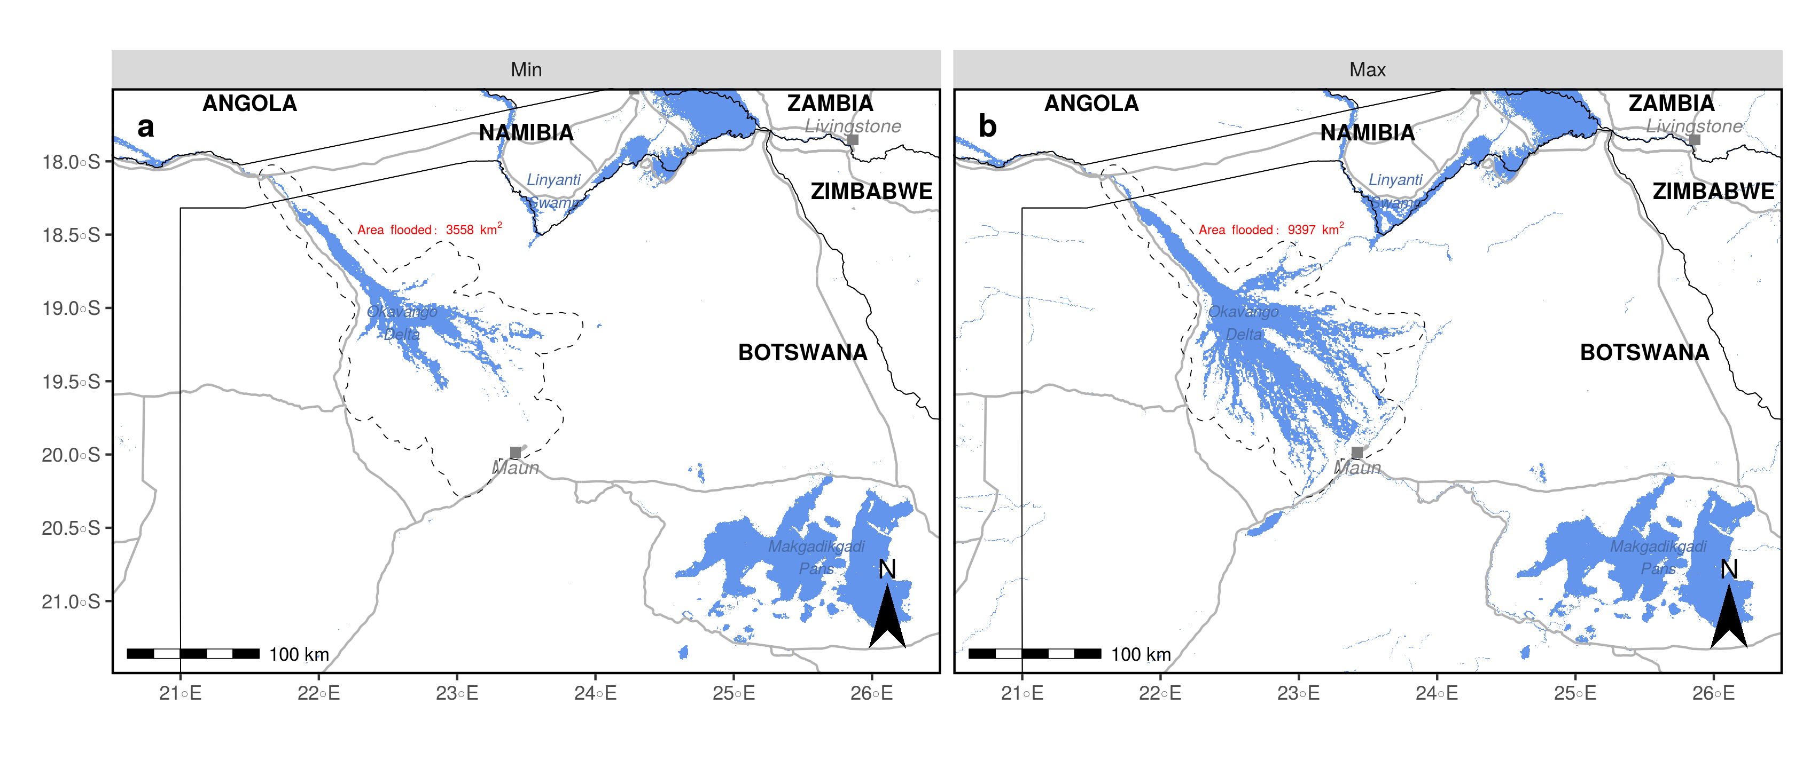

Flood extent in the minimum (a) and maximum (b) flood scenarios. In the minimum flood scenario (a), water stretched across 3’558 km2, whereas during maximum flood (b) it covered 9’397 km2. The two maps were generated using 700 remote sensed MODIS MCD43A4 satellite images spanning the years 2000 to 2019.

## Source Areas and Emigration Zones

We simulated dispersing AWDs originating from six distinct source areas located in the vicinity of the OD (). We placed source areas in regions that remained dry during both the minimum and maximum flooding scenario and are known to host viable wild living wild dog populations. While source areas one to five were located across the delta’s periphery, source area six laid in the OD’s center. The selection of distinct source areas served to facilitate the identification and quantification of the number of successful dispersal events between different regions of the OD. Besides source areas, we also generated “emigration zones” that we used as checkpoints to determine if and where simulated individuals left the delta’s immediate surroundings (). We generated these zones by first overlaying the OD with an elliptic that we dissected into roughly equally sized polygons in accordance with cardinal points ().

## Dispersal Simulation

We used a previously parameterized and validated dispersal model to simulate dispersal of AWDs. The dispersal model was trained using GPS data of 16 wild dog coalitions dispersing across northern Botswana (**???**) which was fed into an integrated step-selection function (iSSF, (Avgar et al. 2016)). In iSSFs, consecutive GPS locations are converted into steps (the straight-line traveled between two GPS recordings (**???**)) and compared to a set of *random* steps in a conditional logistic regression framework (Fortin et al. 2005; Thurfjell, Ciuti, and Boyce 2014; Muff, Signer, and Fieberg 2020; Fieberg et al. 2021). Because iSSFs capitalize on the autocorrelated nature of the collected data, they provide better estimates of connectivity than traditional resource selection approaches (Zeller et al. 2016). The model presented in (**???**) comprised of a movement kernel, describing how dispersers move across the landscape in the absence of habitat selection, a habitat kernel, indicating preferred or avoided habitat features, and interactions among the two, i.e. how movement behavior changes depending on habitat conditions. According to this model, the main characteristics of AWD dispersal movements are avoidance of water, avoidance of areas influenced by humans, and a preference for directional and fast movements. The model parameters are provided in Appendix SX and explained in (**???**).

Originating from each of the six source areas, we simulated 2’000 individuals dispersing for a total of 2’000 steps. 1’000 individuals were simulated assuming a minimum flood, the remaining 1’000 assuming a maximum flood. This resulted in the simulation of a total of 12’000 individuals. The simulation procedure was based on the algorithm described in (**???**) and works as follows. A random location within the source area is defined as starting point. Originating from the starting point, a set of 25 random steps is generated by sampling step lengths from a gamma distribution fitted to observed steps (shape = 0.37, scale = 6’316) and turning angles from a uniform distribution ($−π,+π$). Along each random step the underlying spatial covariates are extracted, and relevant movement metrics are computed. $β−$ estimates from the fitted model are used to predict the probability of each step for being chosen, given the steps associated covariates. Among the 25 proposed steps, one is chosen at random based on assigned probabilities. The location of the animal is updated, and the procedure is repeated until the desired number of steps is realized. Here, we simulated each individual for 2’000 steps, corresponding to a dispersal duration of 400 days and the longest dispersal duration recorded in this study area (Cozzi et al. 2020; Hofmann et al. 2021). The simulated trajectories can be understood as correlated random walks.

## Derived Metrics

Based on simulated dispersal trajectories we quantified connectivity and identified areas of elevated potential for human wildlife conflict. Our assessment of connectivity was based on the three complementary connectivity metrics for IBMMs discussed in (**???**). The set of metrics comprised of *heatmaps*, depicting areas of intense use, *betweenness maps*, highlighting dispersal corridors and bottlenecks and *maps of inter-patch connectivity*, visualizing dispersal success, and duration into distinct habitat patches. We generated heatmaps by superimposing the study area with a grid with a spatial resolution of 1 km and quantifying the frequency of simulated trajectories traversing each grid cell. To compute spatially mapped betweenness scores, we overlaid the study area with a grid that had a resolution of 2.5 km and determined the frequency at which simulated individuals transitioned from one grid-cell to another. A cell-transition was said to occur whenever a simulated step crossed from one grid-cell across or into another. In case the same individual repeatedly realized the same cell-transition, we only counted a single transition to avoid emphasis on regions where individuals moved in circles. This resulted in a weighted edge-list that we used to compute weighted betweenness scores for each grid-cell, i.e. the importance of the respective grid-cell in facilitating movement into adjacent areas (**???**; **???**). Betweenness was computed using the igraph R-package (**???**). Because the computations associated with calculating betweenness scores are computationally more demanding, we deemed the grid size of 2.5 km a sensible compromise between efficiency and resolution. As a final connectivity metric, we computed the number of successful dispersal events between each of the six distinct source areas. We coin this type of connectivity “inter-patch connectivity”. Dispersal between two areas was said to be successful whenever the trajectory of an individual leaving one area intersected with the polygon of another area. We also estimated the number of individuals that left the OD’s vicinity and moved into an emigration zone. To quantify the dispersal durations required to move between source areas or into emigration zones, we recorded the minimum number of steps that individuals moved before arriving at the respective destination. Besides connectivity, we also identified zones with a high potential for human wildlife conflict. For this, we isolated all simulated locations where simulated individuals moved within 500 meters of the nearest human-influenced grid-cell. Based on the so isolated coordinates we generated density maps. To highlight differences between derived metrics during maximum and minimum flooding, we computed difference maps for the heatmap, betweenness map, and human wildlife conflict maps.

# Results

Figures depicting the derived connectivity and human-wildlife conflict maps are provided in . Difference maps to visualize the differences between minimum and maximum flood are given in . For brevity, we will here focus on system-wide connectivity patterns and only selectively point to regional results. Local connectivity maps derived for each source-area separately are presented in the Appendix. As the heatmaps in a reveal, the OD acts as major dispersal barrier during maximum flood yet reveals vital dispersal habitat during minimum flood. Differences between maximum and minimum flood (a) are particularly pronounced for the region between source areas 1 and 2, where few dispersers occur during times of maximum flood. In fact, because the floodwaters of the OD reach almost into Maun, the OD creates a line of separation between its eastern and western sections. The separation is further amplified as the city of Maun is avoided by dispersers in both scenarios. Similar patterns are observed on the betweenness maps (b), where several pinch-points and bottlenecks linking source area 6 to the surrounding source areas exist during minimum flood. During maximum flood, however, these links vanish and instead a single corridor at the south-eastern tip of the OD emerges (b). Despite its apparent importance in linking the eastern and western sections of the delta, it is evident from (a) that this corridor is only rarely used, especially during the maximum flood scenario. As for the potential for human wildlife conflict, two clusters emerge (c). The first cluster lies at the inflow of the Okavango Delta between source areas 4 and 5 and is most pronounced during minimum flood (c). Another, albeit visually less distinct, cluster covers the area at the distal end of the OD, stretching from lake Ngami to Maun. This area appears particularly relevant at maximum flood (c). Our analysis of inter-patch connectivity further demonstrates notable differences in dispersal prospects and dispersal durations depending on the extent of the flood (d and ). While $\input{99_NumberReachingOthersMinFlood.tex}$ simulated dispersers reach another source area during minimum extent, only $\input{99_NumberReachingOthersMaxFlood.tex}$ do so during maximum extent, thus indicating an overall decrease in dispersal success of $\input{99_NumberReachingOthersPercentage.tex}$% during maximum flood. Concomitantly, the average minimum dispersal durations increases by $\input{99_StepsToReachingOthersPercentage.tex}$%, i.e. from $\input{99_NumberReachingOthersMinFlood}$ steps to $\input{99_NumberReachingOthersMaxFlood}$ steps during maximum flood. These differences are particularly pronounced for individuals dispersing into source area 6 on Chief’s Island. While the area is reached by $\input{99_NumberReachingArea6MinFlood.tex}$ simulated individuals during minimum flood, only $\input{99_NumberReachingArea6MaxFlood.tex}$, i.e. $\input{99_NumberReachingArea6Percentage.tex}$% less, arrive there during maximum flood. Furthermore, the dispersal duration into source area six from any other source area increases by $\input{99_StepsToReachingArea6Percentage}$% from $\input{99_StepsToReachingArea6MinFlood.tex}$ steps to $\input{99_StepsToReachingArea6MaxFlood.tex}$ steps. In few occasions, connectivity between some areas increased during maximum flooding, for instance. ..

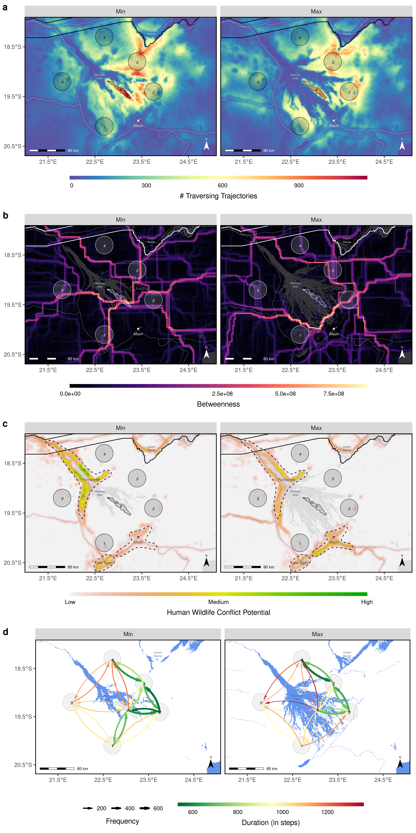

(a) Heatmaps, (b) betweenness maps, (c) maps of human wildlife conflict, and (d) maps of inter-patch connectivity, derived from simulated dispersal events. Left panels were derived from the minimum flood scenario, right panels from the maximum flood scenario. Source areas from which dispersers were released are numbered 1-6. The color scale for betweenness scores in (b) was square-rooted to improve visibility of corridors with lower values. Note that for clarity in (d) we only present links between adjacent source areas. Additional, source-specific maps for each of the four metrics are provided in the appendix.)

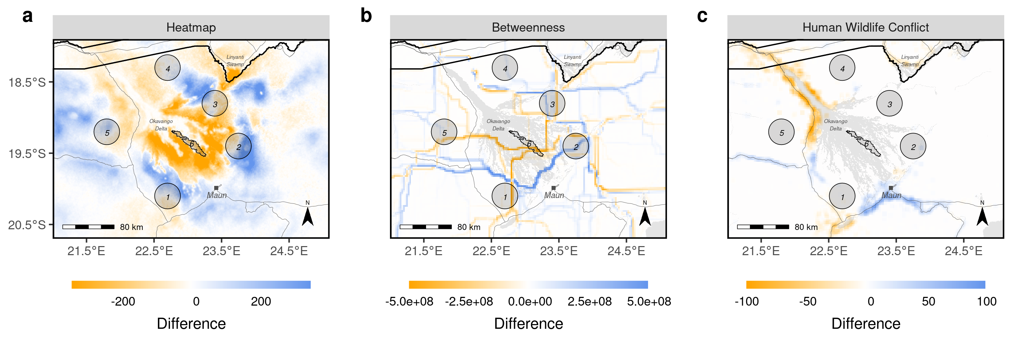

Difference maps generated from the (a) heatmaps, (b) betweenness maps, and (c) maps of human wildlife conflict in . The maps depict the difference between maximum and minimum flood for each metric (i.e. $Metric_{flood:max}−Metric_{flood:min}$). Orange regions indicate that the respective metric was higher during minimum flood, blue regions that the metric was higher during maximum flood.

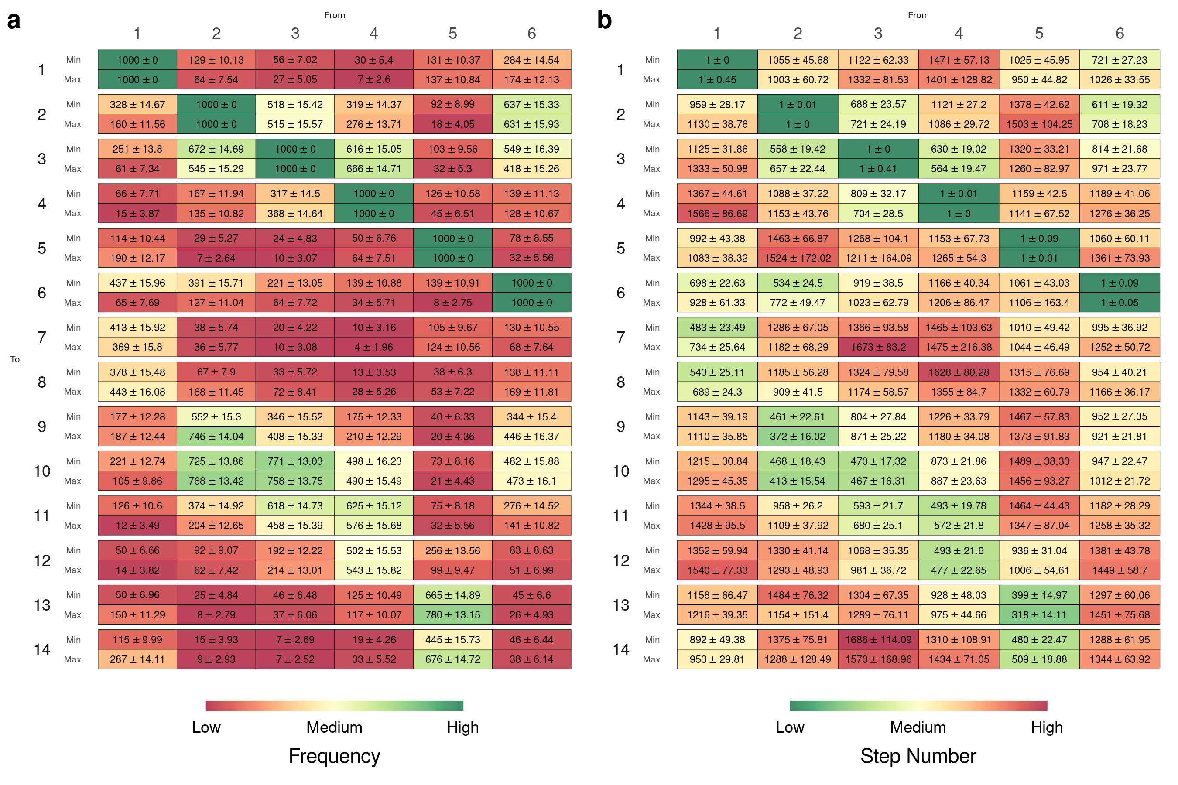

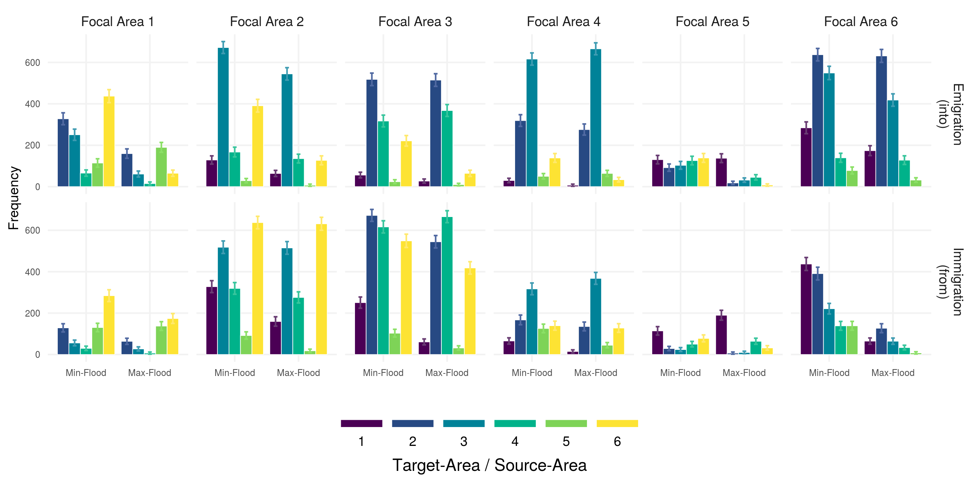

Caption

# Discussion

## Brief Summary

In this study, we used a previously parameterized and validated model to simulate the dispersal movements of AWDs across the OD under two extreme environmental scenarios: one representing minimal flooding and one representing maximum flooding. This approach allowed us to investigate connectivity patterns that emerge under extreme environmental conditions, similar to those projected under climate change. Although accurate predictions of future flood conditions across the OD remain impossible, it is generally assumed that climate change will lead to increased climatic variability and, therefore, more extreme flood events. Our two reference scenarios thus served to approximate two potential realizations. By providing a comprehensive set of connectivity maps for both scenarios, we shed light on the probable consequences of extreme flood events on the dispersal routes and prospects of the endangered AWD. Our simulations indicated that the propensity for dispersers to move between the eastern and western sections of the OD was significantly lower during maximum flooding. This effect likely resulted from the combined influence of floodwaters and anthropogenic pressures, which together acted as a dispersal barrier and limited connectivity. When flooding was at a minimum, on the other hand, the retracted floodwaters revealed vital dispersal habitats that facilitated movement between the western and eastern regions of the OD. Anecdotal evidence supports the notion that this area is only available during minimum flood, for the only dispersal coalition recorded to move across this area was during times of low flood (Cozzi et al. 2020). The lack of dispersal habitat during maximum flood resulted in an almost complete isolation of Chief’s Island, the OD’s central peninsular. While the area remains dry across both scenarios, it becomes entirely surrounded by water at times of maximum flood, thus limiting pathways to emigrate or immigrate.

## Human Wildlife Conflict

It is well documented that a close proximity between humans and wildlife increases the likelihood of human-wildlife conflict (e.g. (**???**) or (**???**)), hence areas where dispersers closely approach human-inhabited regions can be considered as areas with elevated potential for human wildlife conflict. It has been suggested that climate change will increase competition for scarce resources and thereby amplify human-wildlife conflicts on a global scale (**???**). Our simulations showed that dispersers utilize different routes depending on flood conditions thus come into proximity of human impacts in different areas. During minimum flood, these areas were most prominent along the OD’s panhandle, i.e. where the Okavango River enters the alluvial fan of the OD. The panhandle is inhabited comparably densely ($\input{99_HumanDensityPanhandle.tex}$ inh. / km2) and used for both agricultural farming ($\input{99_AgriculturePanhandle.tex}$% covered by agricultural fields) and livestock farming ($\input{99_CattleDensityPanhandle.tex}$ cattle / km2). It has previously received attention as a hotspot for human-wildlife conflict due to repeated elephant raids (**???**) and repeated carnivore attacks on livestock (**???**). During maximum flood, in contrast, a larger number of dispersers moved into the vicinity of Maun and the adjacent region of Lake Ngami at the southern tip of the OD. Maun is the biggest and most densely populated city in the study area ($\input{99_HumanDensityMaun.tex}$ inh. / km2) and serves as hub for touristic excursions into the OD. It’s surrounding landscape is less intensively farmed for agricultural purposes ($\input{99_AgricultureMaun.tex}$% covered by agricultural fields) but the livestock density is comparably high ($\input{99_CattleDensityMaun.tex}$ cattle / km2). Despite this and the fact less than 3% of livestock depredations can be linked to AWDs, there have been numerous occasions where AWDs were harmed or killed within the city’s proximity by retaliating farmers (**???**). While the panhandle and the city of Maun themselves are unprotected, they are located near formally protected areas and may thus serve as ecological traps for wildlife leaving the surrounding protected areas (Woodroffe and Ginsberg 1998; **???**). Dispersing individuals appear to be particularly at risk, as they readily venture outside protected areas into hostile landscapes (Cozzi et al. 2020). It has previously been suggested that dispersal and the associated mortality have caused a net loss of genetic diversity across some of the AWD’s range (Leigh et al. 2012). Our results highlight that future flooding conditions likely determine into which human-dominated areas dispersers get funneled. Interventions to conserve and sustain dispersal pathways will critically depend on our ability to anticipate regional hotspots of human-wildlife conflict, as only this will allow to prioritize efforts and to more efficiently achieve connectivity goals.

## Anthropogenic Resistance

To this day, the social acceptance of AWDs among the local population of northern Botswana has not been investigated. This prohibits a deeper understanding of the anthropogenic resistance experienced by dispersing individuals (**???**). Talk a bit about anthropogenic resistance. While our dispersal model rendered dispersers’ behavior with regards to the presence of humans, it did not take human bheavior into account. This is generally referred to as anthropogenic resistance. The employed dispersal model rendered how biophysical elements and anthropogenic presence influence dispersal movements. It did not, however, account for social or anthropogenic resistance. Corridors that are estimated based on landscape features only may over- or under-estimate true connectivity. Overestimate in areas where there is strong anthropogenic resistance (e.g. hunting, trapping) - Underestimate in areas where humans facilitate movements (e.g. through supplementary food supplies). The flood might funnel individuals into unsafe areas with high risk of human-caused mortality (**???**) (i.e. ecological traps). Depending on the flood, individuals get funneled towards different regions of high anthropogenic influence, suggesting that climate change may induce spatial shifts in regions with a high potential for human wildlife conflict. Depending on the level of anthropogenic resistance that dispersing wild dogs experience in the different areas, these regions may act as ecological traps into which individuals get funneled due to external conditions.

## Social Resistance

While our simulation approach considered the impacts of environmental features on dispersal behavior, it neglected potential interactions between dispersing AWDs and their conspecifics, predators, or pray. This was a simplifying assumption and owed to a lack of data on sympatric species at the appropriate temporal and spatial scale. According to the social resistance hypothesis, however, dispersers’ movement patterns are likely to be driven not only by environmental features, but by a combination of environmental-, intra-, and interspecific conditions (Armansin et al. 2019). Previously, intra- and inter-specific factors have been identified as important aspects of dispersers’ social landscape through which they disperse (**???**). The importance of the social landscape has previously been demonstrated for dispersing meerkats (*Suricata suricatta*), a species surprisingly similar to the AWD in terms of its social organization and dispersal behavior (Cozzi et al. 2018). Accounting for the social landscape will add another level of realism to connectivity studies, but also bring additional complications, particularly in light of climate change. Since the interacting species cannot be considered independent of each other, predicting the movement corridors under future conditions for one species also requires an understanding of the spatial distribution of the other species under the predicted conditions. AWDs, for instance, are considered subordinate competitors that generally avoid dominant competitors (especially lions) in space and or time (**???**). Dispersers are therefore likely to mitigate antagonistic interactions by evading areas that are already occupied by resident conspecifics and competitors. At the same time, dispersers are typically scanning for a suitable home range and searching for potential mates and thus likely attracted by cues of prey and other-sex dispersers. Recently, it has been discovered that AWDs rely on so called “shared marking sites” for advocating their presence and reproductive status (**???**; **???**). While the sites are primarily used by neighboring packs to deploy their scents, even dispersing individuals and competing predators will visit the sites to obtain information on the presence of others (**???**). This could allow dispersers to avoid risky encounters and more effectively locate potential mates. A deeper understanding of these processes is currently lacking and will necessitate the collection of additional data.

The flood extent is likely to have a cascading effect through the species that together form a trophic chain. To avoid competition with lions, wild dogs usually settle in areas of moderate prey availability.

Previous studies on resident lions revealed that extreme flooding causes habitat loss and results in crowding of lions and increased competition over remaining habitats (**???**).

Floods can affect the availability of prey for wild dogs, as well as the distribution and density of other species that compete with wild dogs for resources. For example, if floods lead to an increase in prey availability, wild dogs may have more food resources and their population may increase. On the other hand, if floods lead to a decrease in prey availability, wild dogs may have to compete more intensely with other predators for food, which can affect their survival and reproduction. Additionally, floods can also affect the distribution and density of other predators in the delta, which can affect the competition for resources and ultimately the wild dog population.

We have here focused on a single species, namely the endangered AWD. Climate change and anthropogenic use will result in trophic ripple effects (**???**). Climate change affects species distribution through habitat suitability, which determines structural connectivity which ultimately determines functional connectivity. How climate change will affect the distribution of African wild dogs is not known. Given that the species has occured across the entire Sub-Saharan continent suggests that this species is highly adaptable and limited mainly by the presence of humans, yet less by the habitat itself. In fact, wild dogs have been found on mount Kilimandjaro.

Here, we investigated the consequences of environmental change on the dipsersal behavior of AWDs, implicitly assuming that AWD’s habitat- and movement preferences remain unchanged. For example, we presumed that

... but may mask ...

For the Okavango delta in particular, (**???**) has shown striking differences in habitat selection of *Syncerus caffer* depending on the flood extent. Similar findings were made by ...

Say that an extended flood will reduce connectivity but that a reduced flood may lead to reduced or concentrated prey density, with elevated competition among predators, among which the African wild dog is the inferior species.

The OD is an important driver of species distribution and it has been found that an expanding flood limits available habitat, thus leading to more inter-specific competition, particularly between AWDs and lions (Robynne). Although the OD is arguably the main driver of seasonal change across the studied ecosystem, there are several other factors that undergoe seasonal change, including vegetation and the abundance and distribution of prey or predators.An additional complication arises when species movement is not solely driven by environmental conditions, but also affected by itra- and inter-specific factors. For instance, ... has shown that dispersers... Rendering such conditions alone is challenging, yet rendering the conditions under changing environmental conditions is merely impossible. As highlighted in the papers presented in the intro, climate change change environmental conditions, and in return species distribution, which will, may ultimately culminate in alterations of community composition (**???**). Previous studies have shown that intra-specific factors are imortant determinants of dispersal movements (Cozzi et al. 2018) and it can be expected that inter-specific factors are similarly important (Armansin et al. 2019). Through changing environmental conditions, climate change will also impact the distribution of various species with far-reaching consequences on inter- and intra-specific competition (Abrahms). Due to a lack of data, we omitted any inclusion of social factors in our dispersal model, albeit they are known to be important determinants of dispersal (Armansin). Studying how climate change influences species distribution and their interactions, and ultimately how this alters dispersal, will be challenging but necessary to more realistically simulate dispersal.

## Effect of Climate Change on the Okavango Delta

Despite the importance of the OD as a driver of ecosystem functioning, species distribution, and dispersal patterns, predicting flood patterns under future conditions has proven notoriously difficult (**???**). This is owed to the intricate interplay between climatic conditions, anthropogenic water usage, and the topography of the region. Southern Africa is projected to face temperature rises above the global average (**???**), potentially causing a more intense but shorter rainy season in Botswana (**???**). Precipitation across the ODs catchment areas in Angola, on the other hand, is expected to increase and it remains unclear whether elevated precipitation levels will be offset by increased temperatures and accelerated evapotranspiration (**???**; **???**). In a recent study, (**???**) used three climate models and found that predicted conditions across the delta may range from “much wetter” to “much drier”, with little agreement between the different models. Predictions of future conditions across the OD are further complicated by multi-decadal oscillations in precipitation patterns in Angola that cause shifts between wet and dry periods and may offset or amplify long term trends over short periods (**???**; **???**). Besides these climatic uncertainties, the OD’s future is also plagued by social uncertainties. The OD and its tributaries represent important water-sources for adjacent communities and are subject to intense developmental debates about future abstractions. These result from an ever-growing human population, increasing socio-economic needs, and resettlement in Angola following peace (**???**). This has in large uncertainties regarding the dimensions of future water abstractions (**???**). Although upstream abstractions along the Okavango River are thought to have relatively little impact on the flooding pattern of the OD, the combined effects of climate change and anthropogenic abstractions could result in significant “delta-drying” (**???**). Finally, the region’s shallow gradient (1:3300, (Gumbricht et al. 2004)) represents another source of uncertainty that makes accurate predictions of the spatial extent of the flood unlikely. Even seemingly small changes to the landscape, such as a new channel formed by hippos, can alter the distribution of water across vast extents (McCarthy, Bloem, and Larkin 1998). Because of the large uncertainties surrounding the future flooding patterns of the OD and associated changes in its biosphere, designing appropriate conservation strategies remains challenging. Instead of focusing on single future scenarios, dynamic and flexible conservation plans will need to be designed.

## Seasonality in Dispersal Models

While our analysis marks an important step into incorporating environmental change into studies of connectivity, there are several critical additions that should be considered by future studies. We studied dispersal and connectivity under two extreme environmental scenarios, yet our movement model assumed that dispersers had identical habitat and movement preferences in both scenarios. In reality, however, it can be expected that movement and habitat kernels of dispersers differ depending on the season considered (examples). Can incporporate seasonality by keeping environmental conditions constant, but rendering changes in species habitat preferences. Or, keep species habitat preferences constant and vary the environemnt. Or both. To address such differences, researchers could model habitat and movement preferences using season-dependent models, or, alternatively, by combining hidden markov models with step-selection functions. (cite papers that fieberg sent)

Connectivity analyses that omit dynamism, be it due to seasonality or climate change, not only fail to capture an important aspect of reality, but also forego the ability to gain an understanding of connectivity under “non-average” conditions, such as those expected under climate change. Reqires more data on dispersers -> Difficult to get -> Link to citizen science

## Validating Predictions

Although the model underlying our simulations has been validated using independent dispersal data, quantifying the reliability of our connectivity predictions under extreme flooding remains challenging. Firstly, because collecting data of dispersing individiauls is challenging per se, thus limiting the amount of independent data that can be used for validation. Secondly, the respective data would need to be collected during extreme flooding to be informative with the processes being studied here. However, instead of relying purely on GPS movement data, alternative methods may be employed. The ultimate measure of connectivity is geneflow, hence genetic data provides the most reliable evidence for effective dispersal. Recent genetic analysis across southern Africa revealed moderate levels of dispersal (**???**) and identified a genetically particularly diverse population cluster located near northern Botswana. While genetic analysis like these provide valuable insights into long-term dispersal patterns, they prohibit investigating differing dispersal patterns depending on seasonal fluctuations. Although additional GPS data from dispersing AWDs across a larger study area would be invaluable for this, it is logistically unfeasible and ethically questionable to try and equip dispersers across the entire delta. One promising alternative is employ a citizen science approach and to capitalize on the many tourists visiting the OD. Most large carnivores, in particular AWDs, exhibit unique spot patterns or fur markings that allow individual identification. Through photographic evidence from tourists, dispersal across large distances could be observed. Such undertakings are critical for species that disperse across borders and beyond confined study areas. Novel deep learning tools, such as the carnivore wildbook (ACW; <https://africancarnivore.wildbook.org>), offers a computer-assisted workflow to efficiently and effectively identify individuals. We are studying a rare event and dispersers are rare too.

## Conclusion

Our dispersal simulations across two extreme environmental scenarios revealed striking differences in dispersal prospects and landscape connectivity for dispersing AWDs. We thereby showed that extreme environmental conditions, akin to those projected under climate change, will have important impacts on functional connectivity for dispersing species and could shift human-wildlife conflict into new areas. Given the complexity of the studied ecosystem and its associated intricate feedback loops, predictions of future conditions remain challenging and plagued by uncertainty. Wildlife managers and conservation bodies therefore do not have the luxury of being able to focus on a single future scenario, but must remain flexible to adequately respond to changes in the environment due to climate change. This requires the development of protection strategies that can accommodate both more extreme pronounced, or less intense flood, while also coping with an ever expanding human population and associated impacts of wildlife. Successful conservation strategies will be of particular relevance for wide-ranging, endangered species that are already at the verge of extinction, such as the African wild dog.

# Authors’ Contributions

D.D.H., G.C., D.M.B., A.O. and conceived the study and designed methodology; D.D.H., G.C., D.M.B., and J.W.M. collected the data; D.D.H. analysed the data; G.C., D.M.B., and A.O. assisted with modeling; D.D.H., G.C., and D.M.B.wrote the first draft of the manuscript and all authors contributed to the drafts at several stages and gave final approval for publication.

# Data Availability

Access to R-scripts to replicate our anlaysis will be provided through an online repository at the time of publication.

# Acknowledgements

We thank the Ministry of Environment and Tourism of Botswana for granting permission to conduct this research. We thank C. Botes, I. Clavadetscher, and G. Camenisch for assisting with wild dog immobilizations. We also thank B. Abrahms for sharing her data of three dispersing wild dogs. This study was funded by Albert-Heim Foundation, Basler Stiftung für Biologische Forschung, Claraz Foundation, Idea Wild, Jacot Foundation, National Geographic Society, Parrotia Stiftung, Stiftung Temperatio, Wilderness Wildlife Trust Foundation, Forschungkredit der Universität Zürich, and a Swiss National Science Foundation Grant (31003A_182286) to A. Ozgul.

Adriaensen, F., J. P. Chardon, G. De Blust, E. Swinnen, S. Villalba, H. Gulinck, and E. Matthysen. 2003. “The Application of Least-Cost Modelling as a Functional Landscape Model.” *Landscape and Urban Planning* 64 (4): 233–47.

Allen, Corrie H., Lael Parrott, and Catherine Kyle. 2016. “An Individual-Based Modelling Approach to Estimate Landscape Connectivity for Bighorn Sheep (Ovis canadensis).” *PeerJ* 4: e2001. <https://doi.org/10.7717/peerj.2001>.

Armansin, Nicolette C., Adam J. Stow, Mauricio Cantor, Stephan T. Leu, James A. Klarevas-Irby, Anthony A. Chariton, and Damien R. Farine. 2019. “Social Barriers in Ecological Landscapes: The Social Resistance Hypothesis.” *Trends in Ecology & Evolution*.

Avgar, Tal, Jonathan R. Potts, Mark A. Lewis, and Mark S. Boyce. 2016. “Integrated Step Selection Analysis: Bridging the Gap Between Resource Selection and Animal Movement.” Edited by Luca Börger. *Methods in Ecology and Evolution* 7 (5): 619–30.

Baguette, Michel, Simon Blanchet, Delphine Legrand, Virginie M. Stevens, and Camille Turlure. 2013. “Individual Dispersal, Landscape Connectivity and Ecological Networks.” *Biological Reviews* 88 (2): 310–26.

Behr, Dominik M, J. Weldon McNutt, Arpat Ozgul, and Gabriele Cozzi. 2020. “When to Stay and When to Leave? Proximate Causes of Dispersal in an Endangered Social Carnivore.” *Journal of Animal Ecology* 89 (10): 2356–66.

Boyce, Mark S., Pierre R. Vernier, Scott E. Nielsen, and Fiona K. A. Schmiegelow. 2002. “Evaluating Resource Selection Functions.” *Ecological Modelling* 157 (2-3): 281–300.

Brennan, A., P. Beytell, O. Aschenborn, P. Du Preez, P. J. Funston, L. Hanssen, J. W. Kilian, G. Stuart‐Hill, R. D. Taylor, and R. Naidoo. 2020. “Characterizing Multispecies Connectivity Across a Transfrontier Conservation Landscape.” *Journal of Applied Ecology* 57: 1700–1710.

Brown, James H., and Astrid Kodric-Brown. 1977. “Turnover Rates in Insular Biogeography: Effect of Immigration on Extinction.” *Ecology* 58 (2): 445–49.

Clobert, Jean, Michel Baguette, Tim G. Benton, and James M. Bullock. 2012. *Dispersal Ecology and Evolution*. Oxford, UK: Oxford University Press.

Cozzi, Gabriele, Dominik Behr, H Webster, M Claase, CM Bryce, B Modise, JW McNutt, and Arpat Ozgul. 2020. “The Walk of Life: African Wild Dog Dispersal and its Implications for Management and Conservation across Transfrontier Landscapes.”

Cozzi, Gabriele, Nino Maag, Luca Börger, Tim H. Clutton-Brock, and Arpat Ozgul. 2018. “Socially Informed Dispersal in a Territorial Cooperative Breeder.” Edited by Garrett Street. *Journal of Animal Ecology* 87 (3): 838–49.

Cushman, Samuel A., and Jesse S. Lewis. 2010. “Movement Behavior Explains Genetic Differentiation in American Black Bears.” *Landscape Ecology* 25 (10): 1613–25.

Diniz, Milena F., Samuel A. Cushman, Ricardo B. Machado, and Paulo De Marco Júnior. 2019. “Landscape Connectivity Modeling from the Perspective of Animal Dispersal.” *Landscape Ecology* 35: 41–58. <https://doi.org/10.1007/s10980-019-00935-3>.

Doerr, Veronica A. J., Tom Barrett, and Erik D. Doerr. 2011. “Connectivity, Dispersal Behaviour and Conservation under Climate Change: A Response to Hodgson et al.: Connectivity and Dispersal Behaviour.” *Journal of Applied Ecology* 48 (1): 143–47.

Eddelbuettel, Dirk, and Romain François. 2011. “Rcpp: Seamless R and C++ Integration.” *Journal of Statistical Software* 40 (8): 1–18. <https://doi.org/10.18637/jss.v040.i08>.

Elliot, Nicholas B., Samuel A. Cushman, David W. Macdonald, and Andrew J. Loveridge. 2014. “The Devil is in the Dispersers: Predictions of Landscape Connectivity Change with Demography.” Edited by Nathalie Pettorelli. *Journal of Applied Ecology* 51 (5): 1169–78.

Etherington, Thomas R. 2016. “Least-Cost Modelling and Landscape Ecology: Concepts, Applications, and Opportunities.” *Current Landscape Ecology Reports* 1 (1): 40–53. <https://doi.org/10.1007/s40823-016-0006-9>.

Fahrig, Lenore. 2003. “Effects of Habitat Fragmentation on Biodiversity.” *Annual Review of Ecology, Evolution, and Systematics* 34 (1): 487–515.

Fieberg, John, Johannes Signer, Brian Smith, and Tal Avgar. 2021. “A ‘How to’ Guide for Interpreting Parameters in Habitat-Selection Analyses.” *Journal of Animal Ecology* 90 (5): 1027–43.

Fortin, Daniel, Hawthorne L. Beyer, Mark S. Boyce, Douglas W. Smith, Thierry Duchesne, and Julie S. Mao. 2005. “Wolves Influence Elk Movements: Behavior Shapes a Trophic Cascade in Yellowstone National Park.” *Ecology* 86 (5): 1320–30.

Fortin, Daniel, Marie-Eve Fortin, Hawthorne L. Beyer, Thierry Duchesne, Sabrina Courant, and Karine Dancose. 2009. “Group-Size-Mediated Habitat Selection and Group Fusion–Fission Dynamics of Bison under Predation Risk.” *Ecology* 90 (9): 2480–90.

Frankham, Richard, David A. Briscoe, and Jonathan D. Ballou. 2002. *Introduction to Conservation Genetics*. Cambridge, UK: Cambridge University Press.

Gumbricht, T, P Wolski, P Frost, and T. S McCarthy. 2004. “Forecasting the Spatial Extent of the Annual Flood in the Okavango Delta, Botswana.” *Journal of Hydrology* 290 (3-4): 178–91.

Gustafson, Eric J., and Robert H. Gardner. 1996. “The Effect of Landscape Heterogeneity on the Probability of Patch Colonization.” *Ecology* 77 (1): 94–107. <https://doi.org/10.2307/2265659>.

Hanski, Ilkka. 1999. “Habitat Connectivity, Habitat Continuity, and Metapopulations in Dynamic Landscapes.” *Oikos* 87 (2): 209.

Hauenstein, Severin, Julien Fattebert, Martin U. Grüebler, Beat Naef-Daenzer, Guy Pe’er, and Florian Hartig. 2019. “Calibrating an Individual-Based Movement Model to Predict Functional Connectivity for Little Owls.” *Ecological Applications* 29 (4): e01873.

Heller, Nicole E., and Erika S. Zavaleta. 2009. “Biodiversity Management in the Face of Climate Change: A Review of 22 Years of Recommendations.” *Biological Conservation* 142 (1): 14–32.

Hodgson, Jenny A., Chris D. Thomas, Brendan A. Wintle, and Atte Moilanen. 2009. “Climate Change Connectivity and Conservation Decision Making: Back to Basics.” *Journal of Applied Ecology* 46 (5): 964–69.

Hofmann, David D., Dominik M. Behr, John W. McNutt, Arpat Ozgul, and Gabriele Cozzi. 2021. “Bound Within Boundaries: Do Protected Areas Cover Movement Corridors of Their Most Mobile, Protected Species?” *Journal of Applied Ecology* 58 (6): 1133–44.

Kanagaraj, Rajapandian, Thorsten Wiegand, Stephanie Kramer-Schadt, and Surendra P. Goyal. 2013. “Using Individual-Based Movement Models to Assess Inter-Patch Connectivity for Large Carnivores in Fragmented Landscapes.” *Biological Conservation* 167: 298–309.

Koen, Erin L., Colin J. Garroway, Paul J. Wilson, and Jeff Bowman. 2010. “The Effect of Map Boundary on Estimates of Landscape Resistance to Animal Movement.” *PlOS ONE* 5 (7): e11785.

Kokko, H. 2006. “From Individual Dispersal to Species Ranges: Perspectives for a Changing World.” *Science* 313 (5788): 789–91.

Leigh, Kellie A., Kyall R. Zenger, Imke Tammen, and Herman W. Raadsma. 2012. “Loss of Genetic Diversity in an Outbreeding Species: Small Population Effects in the African Wild Dog (Lycaon pictus).” *Conservation Genetics* 13 (3): 767–77.

MacArthur, Robert H., and Edward O. Wilson. 2001. *The Theory of Island Biogeography*. Vol. 1. Princeton, New Jersey, USA: Princeton University Press.

Masenga, Emmanuel H., Craig R. Jackson, Ernest E. Mjingo, Andrew Jacobson, Jason Riggio, Richard D. Lyamuya, Robert D. Fyumagwa, Markus Borner, and Eivin Røskaft. 2016. “Insights into Long-Distance Dispersal by African Wild Dogs in East Africa.” *African Journal of Ecology* 54 (1): 95–98.

McCarthy, Terence S., A. Bloem, and P. A. Larkin. 1998. “Observations on the Hydrology and Geohydrology of the Okavango Delta.” *South African Journal of Geology* 101 (2): 101–17.

McNutt, J.Weldon. 1996. “Sex-Biased Dispersal in African Wild Dogs (Lycaon pictus).” *Animal Behaviour* 52 (6): 1067–77.

McRae, Brad H., Brett G. Dickson, Timothy H. Keitt, and Viral B. Shah. 2008. “Using Circuit Theory to Model Connectivity in Ecology, Evolution, and Conservation.” *Ecology* 89 (10): 2712–24. <https://doi.org/10.1890/07-1861.1>.

Muff, Stefanie, Johannes Signer, and John Fieberg. 2020. “Accounting for Individual-Specific Variation in Habitat-Selection Studies: Efficient Estimation of Mixed-Effects Models Using Bayesian or Frequentist Computation.” *Journal of Animal Ecology* 89 (1): 80–92.

Osipova, L., M. M. Okello, S. J. Njumbi, S. Ngene, D. Western, M. W. Hayward, and N. Balkenhol. 2019. “Using Step‐Selection Functions to Model landscape Connectivity for African Elephants: Accounting for Variability across Individuals and Seasons.” *Animal Conservation* 22 (1): 35–48.

Ozgul, Arpat, Dylan Z Childs, Madan K Oli, Kenneth B Armitage, Daniel T Blumstein, Lucretia E Olson, Shripad Tuljapurkar, and Tim Coulson. 2010. “Coupled Dynamics of Body Mass and Population Growth in Response to Environmental Change.” *Nature* 466 (7305): 482–85.

Sawyer, Sarah C., Clinton W. Epps, and Justin S. Brashares. 2011. “Placing Linkages among Fragmented Habitats: Do Least-Cost Models Reflect How Animals Use Landscapes?” *Journal of Applied Ecology* 48 (3): 668–78.

Taylor, Philip D., Lenore Fahrig, Kringen Henein, and Gray Merriam. 1993. “Connectivity Is a Vital Element of Landscape Structure.” *OIKOS* 68 (3): 571–73.

Thurfjell, Henrik, Simone Ciuti, and Mark S. Boyce. 2014. “Applications of Step-Selection Functions in Ecology and Conservation.” *Movement Ecology* 2 (4).

Tischendorf, Lutz, and Lenore Fahrig. 2000. “On the Usage and Measurement of Landscape Connectivity.” *Oikos* 90 (1): 7–19.

Vasudev, Divya, Robert J. Fletcher, Varun R. Goswami, and Meghna Krishnadas. 2015. “From Dispersal Constraints to Landscape Connectivity: Lessons from Species Distribution Modeling.” *Ecography* 38 (10): 967–78.

Wolski, Piotr, Mike Murray-Hudson, Kgalalelo Thito, and Lin Cassidy. 2017. “Keeping it Simple: Monitoring Flood Extent in Large Data-Poor Wetlands Wsing MODIS SWIR Data.” *International Journal of Applied Earth Observation and Geoinformation* 57: 224–34.

Woodroffe, R., and Joshua R. Ginsberg. 1998. “Edge Effects and the Extinction of Populations Inside Protected Areas.” *Science* 280 (5372): 2126–8. <https://doi.org/10.1126/science.280.5372.2126>.

Woodroffe, R., and C. Sillero-Zubiri. 2012. “Lycaon Pictus.” *The IUCN Red List of Threatened Species* 2012: e. T12436A16711116.

Zeller, Katherine A., Kevin McGarigal, Samuel A. Cushman, Paul Beier, T. Winston Vickers, and Walter M. Boyce. 2016. “Using Step and Path Selection Functions for Estimating Resistance to Movement: Pumas as a Case Study.” *Landscape Ecology* 31 (6): 1319–35.

Zeller, Katherine A., Kevin McGarigal, and Andrew R. Whiteley. 2012. “Estimating Landscape Resistance to Movement: A Review.” *Landscape Ecology* 27 (6): 777–97.

Zeller, Katherine A., David W. Wattles, Javan M. Bauder, and Stephen DeStefano. 2020. “Forecasting Seasonal Habitat Connectivity in a Developing Landscape.” *Land* 9 (7): 233.